**Mobile Application Development**

Coursework 02 – Group 03

Chandima Athapattu (W1905330 / 20211401)

Kevin Abeysekara (W1867876 / 20210543)

Sewvandi Wickramasinghe (W1898885 / 20211399)

**Overview** **4**

**Objectives** **4**

**Architecture Overview** **4**

**App icon overview** **5**

**Application Screenshots** **6**

**Individual Contribution** **12**

6.1 Chandima Athapattu (w1905330 / 20211401) 12

Introduction: 12

Requirement Stage: 12

Design Stage: 12

Implementation Phase 13

6.2 Sewvandi Wickramasinghe (W1898885 / 20211399) 14

Requirement Stage 14

Design Stage 14

Implementation Phase 15

6.3 Kevin Abeysekara (W1867876 / 20210543) 16

Requirement Stage 16

Design Stage 16

Implementation Phase 17

**Burger Brew**

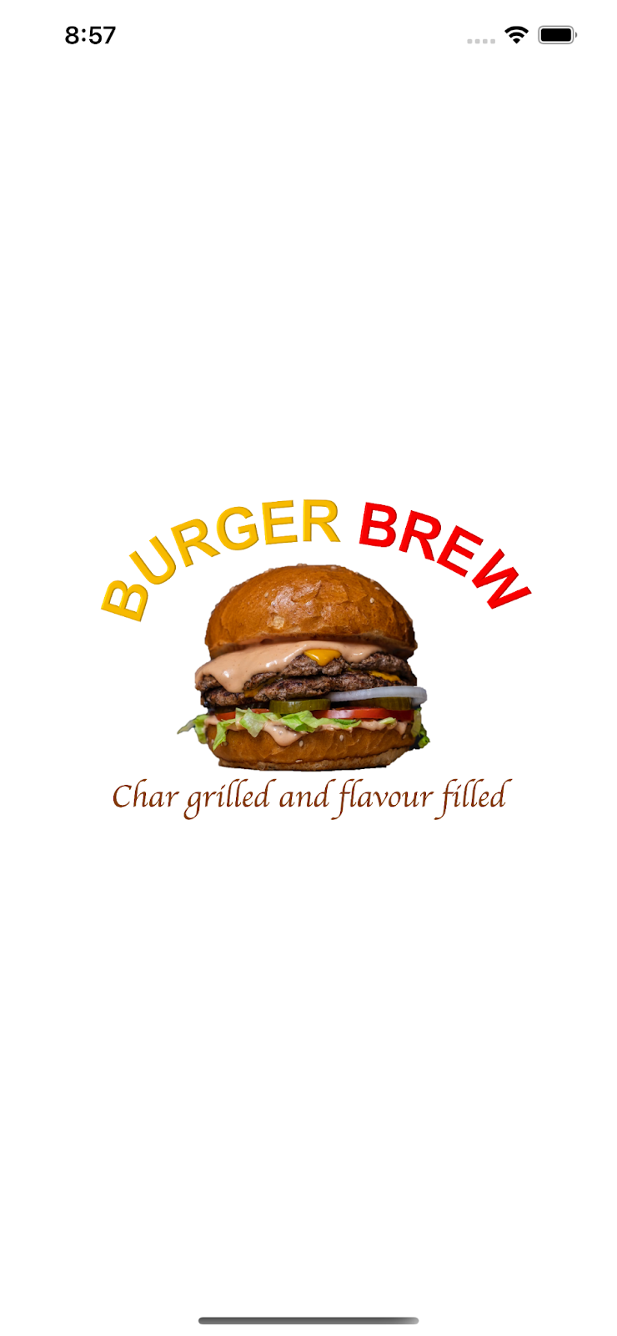

# Overview

* ‘Burger Brew’ is a restaurant that provides a wide variety of burgers for their customers.
* ‘Burger Brew Mobile Application’ designed to order burgers online with ease that provides convenient ordering with cash on delivery for their customers.
* An email notification will be sent to the seller and customer upon order completion.

# Objectives

* Convenient 3 step food ordering.
  + Open ‘Burger Brew’
  + Select your food items
  + Place the order
* Fast confirmation with email notifications.
* Food preferences breakdown for easy ordering.

# Architecture Overview

# App icon overview

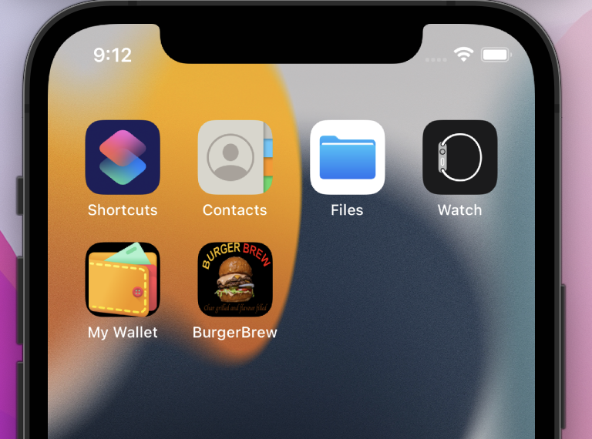

# Application Screenshots

| Splash screen | Home page |
| --- | --- |
|  |  |

| Burger menu | Burger detail page |
| --- | --- |
|  |  |

| Dessert menu | Dessert detail page |
| --- | --- |
|  |  |

| Beverage menu | Beverage detail page |
| --- | --- |
|  |  |

| Cart view | Submit order page |
| --- | --- |
|  |  |

# Individual Contribution

## 6.1 Chandima Athapattu (w1905330 / 20211401)

## Introduction:

BurgerBrew application developed as a solution to ensure fast, convenient food ordering & delivery for their customers. Out team consists three team members (including myself) and finalizing the solution outline, objectives and the future road map is a team work. Below I illustrate the role of myself within the project from inception to delivery.

## Requirement Stage:

As explained above, requirement elicitation is a team work and I contributed to brainstorm the problem and finalizing a viable yet practical solution. Participated to multiple discussion during the initiation phase of the project and drafted the high level solution design with the team which was the basis for the presentation content.

## Design Stage:

During the design stage i prepared below artifacts.

1. High-level components diagram - This diagram explains the high level components of the solution and how the solution drilled-down to sub modules. I segregated the components into three main categories which are storyboards, Item related modules and order related modules.
2. Class diagram - I created the class diagram of the project by identifying the main classes and their relationships.
   1. First identified the three data models which are Burger, Dessert and Beverage.
   2. In-between the ‘Order’ and data models, there is one-to-many relationship respectively.
   3. Secondly identified all the view controllers in the solution and they all related parent UIViewController.
   4. In addition to that identified the TabBarController and TableViewController to implement the navigation tabs and the item list in the cart view.
   5. In addition to above, identified the data model and delegates also in the class diagram.

## Implementation Phase

**UI Images and Design:**

I designed all the pages header images which took considerable time to optimize the resolution and size. And also used premium design service Canva.com to identify suitable images. It was a challenge to pick the correct resolution of the images and different the solution should cater to multiple resolutions.

**Storyboard Design:**

By looking at the wireframes i was able to design the storyboards. We used the same original storyboards in the presentation as screenshots it self without designing any dummy designs.

Thereafter, design below storyboards as the front end design,

* Home page (Scrollable with correct constraints)
* Tab bar view and linked with Burger, Dessert and Beverage pages
* The storyboard sketch of cart view page and delivery pages.

Completed all the navigation in-between home page and item grid views.

**Implementation:**

1. Created the initial project structure in XCode. Grouped the artifacts into sub-folders as, Extensions, CollectionViewCells, Utils, TabBarController, ViewControllers and Models.
2. Done the data model implementation of burger, dessert and beverages.
3. Implemented three collection view cells for burger, dessert and beverages grid views and populated the data models for each item.
4. Implemented tab bar controller for above three item types and the navigation back and forth.
5. Implemented following view controllers fully.
   1. Home_ViewController
   2. BurgerViewController
   3. DessertViewController
   4. BeverageViewController
6. Implemented scrollable pages for all above pages.
7. Implemented the unit and UI tests to test the high-level functionality of the solution.

## 6.2 Sewvandi Wickramasinghe (W1898885 / 20211399)

## Requirement Stage

The three team members on our team, including myself, worked collaboratively on brainstorming the ideas, Identifying a viable solution that fulfills a common problem, and finalizing the solution's description, objectives, and future road map. I took part in several discussions during the project's commencement phase, and the responsibilities I played from project planning to completion are outlined here.

## Design Stage

I prepared the artifacts listed below during the design phase.

Use Case diagram - This diagram explains the high-level functions and scope of the system.

1. First, I determined the two main actors : Burger Brew owner and Burger Brew user
2. Secondly, all the activities that Burger Brew users will perform were identified, and listed all system functions in use cases.
3. Connected the Burger Brew user to the relevant use cases through communication links.
4. Used generalization relationship to show the parent-child relationship between use cases.
5. Identified the Use Case Relationships - extends and include
6. And connected relevant actions to Burger Brew owner.

**Design Wireframes:**

I created all the wireframes to demonstrate how pages are connected in order to link the site's information architecture to its visual design.

| * Splash screen * Home page * Burger menu page * Burger detail page * Dessert menu page | * Dessert detail page * Beverage menu page * Beverage detail page * Place order detail page * Order confirmed popup |
| --- | --- |

## Implementation Phase

**UI Images and Design:**

I made a color scheme with 5 main colours for buttons, backgrounds, titles, and regular texts. For the burger menu, dessert menu, and beverage menu, I fetched images, flat images, and icons in the appropriate resolution from online sources.

**Open source tool for code management :**

For the management of our project and code, I set up a GitHub organization called “Mobile Application Development”. I created a kanban board and listed everything that was "Todo," "In Progress," "Group Review," and "Done", throughout the project. We all used GitHub as our source control during each individual implementation. Using GitHub made it much simpler for us to integrate our separate components into the mobile application development project.

Link to Burger Brew complete source code :<https://github.com/Burger-Brew/BurgerBrewApp>

**Implementation:**

1. Created storyboards and view controllers for Burger Brew
   1. burger detail page
   2. dessert detail page
   3. beverage detail page.
2. Implemented following view controllers fully.
   1. BurgerDetailedViewController
   2. DessetDetailsViewController
   3. BeverageDetailedViewController
3. The implementation phase of my task was quite challenging because I had to pass the images, names, prices, and descriptions of each burger, dessert, and beverage item from the menu page to the appropriate burger, dessert and beverage detail page view controllers.
4. Implemented following extensions.
   1. UIViewController+Extension
   2. String+Extension

## 6.3 Kevin Abeysekara (W1867876 / 20210543)

## Requirement Stage

The three team members on our team, including myself, worked collaboratively on brainstorming the ideas, Identifying a viable solution that fulfills a common problem, and finalizing the solution's description, objectives, and future road map. I took part in discussions during the project's commencement phase, and the responsibilities I played from project planning to completion are outlined here.

## Design Stage

Prepared the artifacts listed below during the design phase.

1. Created the Logo for the Application and
2. Loading Page.
3. Created Icons for the application Tab Bar Controller.

Created the High Level Architectural blueprint - This diagram explains the high-level architecture of the App with technology used for the development of the App.

1. How the user interacts with the Application:

Main Product Category Page -> Product List -> Product Detail Page -> Cart Page -> Delivery Page

1. Processing of the App with Controllers and Delegates
2. Database using Models & Core Data
3. API to connect use SMS, EMAIL, GPS

Edited the Images for improved appeal in the application for attracting Users.

## Implementation Phase

Prototyped Key functions of the Application.

1. Add to Cart Function using Core Data and NSManager
2. Edit Quantity in the product details function and update real time using CallBacks.
3. Change Totals in the Cart based on new quantities.
4. Used CELL NIBs for the Table Views
5. Delete Function of the Cart items.
6. Email function of the app after closing the order. (This needed real device to test)

Applied the prototyped functions on the real Application with modifications to suit the real application requirements and UI/UX requirements.

1. Implemented the Cart View Controller with UIStepper to edit quantities.
2. Implemented Delivery View Controller with the MFMailComposeViewController.
3. Implemented CartViewCell Cell NIB for the Table View of the Cart View Controller, and used Callback function to update the Cart View Controller.
4. Created the CartList CoreData for data persistence of the Cart items.
5. Used all CRUD methods for the CartView Controller.
6. Used Proper Keyboards for the Delivery View Controller form Inputs.
7. Used checks to avoid app crashing during the Email stage if the application is runned on a simulation without an email app.
8. Made Cart View Controller part of the Tab Bar Controller so that users can view Cart status at any time of the ordering process.

<End of Document>